Shazia Sheikh
MD, MBBS, CPE

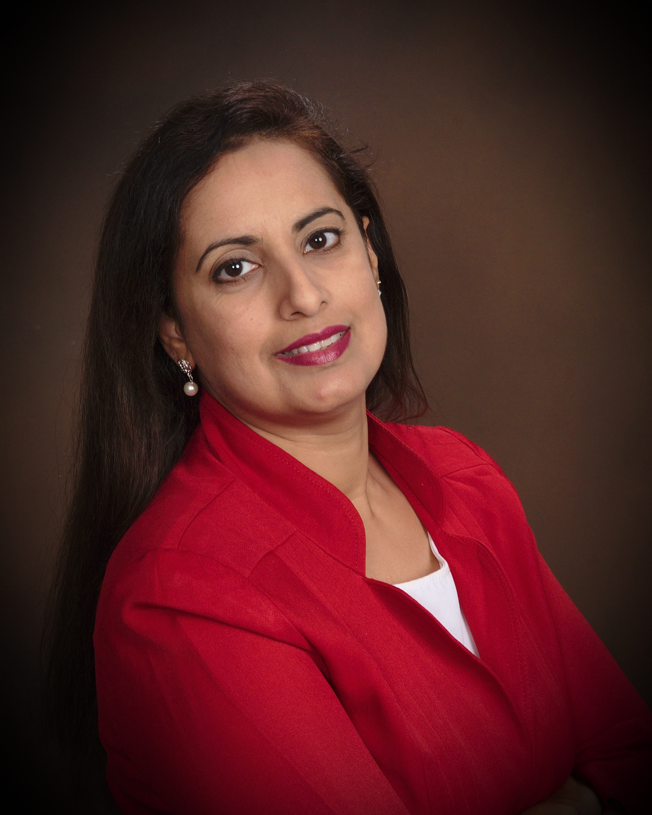

Dr. Sheikh earned her medical degree from The University of Punjab’s Allama Iqbal Medical College. She completed her residency in Guthrie Clinic / Robert Packer Hospital in Pennsylvania. She has practiced Internal medicine in La Fe clinic for about 7 years where she was the Medical representative for Pharmacy and Therapeutics committee, member Diabetes collaborative, member of Professional Review Committee, and Laboratory Medical Director. Since 2010 she has served as Medical director of La Fe CARE clinic, which is the largest Ryan White facility, providing services to patients with HIV/ AIDS in the El Paso and surrounding areas. There she has served as the Chairperson of Performance improvement committee, Chairperson of Infection Control and employee Health committee. She has also served as Clinical Director of Regional Texas / Oklahoma AIDS Education & Training center. She has certified HIV Specialist by American Academy of HIV medicine. She also received her Certified Physician executive certification through ACPE & The certifying commission of Medical Management.
She regularly works as preceptor for GIMSPP to provide Medical training and supervision to medical students to prepare them for patient treatment in the future.
Dr. Sheikh has worked as a Hospitalist and Medical Director for Team Health for last 5 years. She has also served as Physician Advisor and Case Management Director in Memorial Hermann Health System.
She serves as staff Physician for Memorial Hermann Katy Hospital, Houston Methodist West Hospital, Memorial Hermann Katy Rehab Hospital, Encompass Rehab in Katy, Methodist Continuing care Hospital and Oakbend Hospital.
Dr. Sheikh is excited to bring a comprehensive team to offer the best treatment options available to patients.
The treatment of patients with Chronic medical issues like diabetes and prevention of complications has long been an interest for Dr. Sheikh since it was a condition seen so often in her primary care practice. These understandings have enabled healthcare providers like Dr. Sheikh to guide patients to goals proven to prevent complications and improve quality of life. Working with a team makes achieving these goals a reality for patients. Dr. Sheikh enjoys the meaning in her life that comes from guiding a person through difficult terrain to safe ground, especially when they just didn’t think it could be done.
Her clinical interests include Obesity, diabetes in special populations, post-transplantation diabetes, Hypertension and modern insulin therapy.
She chooses to specialize in Obesity therapy because it is a disease that currently affects one in every three individuals. Dr. Sheikh sees her role as a physician as a guide for patients to help control or prevent chronic diseases. She believes that in order for a patient to follow advice, he or she must understand the reason behind it or why it is important.
She likes being an integral part in someone’s life to try to help them make lifestyle changes and live a healthier life. In addition she likes to help people avoid the end-organ damages related to poorly controlled medical conditions and provide them with education.
She believes that good education, prevention, and early intervention are key in the management of the diabetes. She currently lives in the Houston area where she enjoys the busy city lifestyle along with her husband and three children.
She is excited to focus on Primary care at the Crescent Clinic. She champions a patient-centered approach where teaching patients to take control of their own diseases through self-management and life style modification is as important as medical management
Dr. Sheikh enjoys working with each patient to find the appropriate disease management plan that is the best fit for a given patient’s unique set of needs and goals. More medical therapies and products are becoming available, technology is rapidly advancing, and the scientific literature about disease management is prolific and dynamic. It is challenging and rewarding to offer patients the most current therapies and science. Dr. Sheikh is also experienced in managing insulin pump therapy and interpreting continuous glucose monitoring technology. Dr. Sheikh knows achieving the best outcomes in medical care requires an investment in education so that all facets of proper management are covered and all questions are answered to the patient’s satisfaction. Medical care is a continuous learning process for the doctor and for the patient. Our patients find that Crescent Clinic quickly becomes a vital part of their support system.

